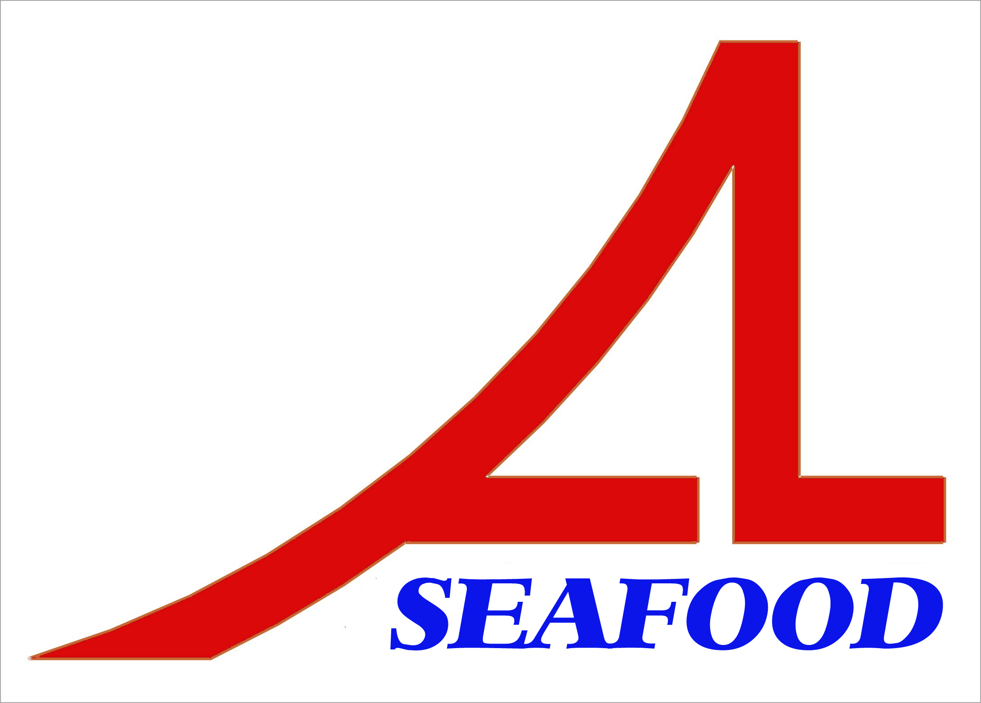AN LAC SEAFOOD CO., LTD.
Lot A14,4A Street, Hai Son Industrial Zone, Duc Hoa District, Long An Province, VietNam.
* E-mail : longan@anlacseafoods.com * Website: www.anlacseafood.com

* Tel : (84) 72 3850606 * Fax : (84) 72 3850608

SALES CONTRACT
No.: 04/AL-CH/16
Date: Apr. 29, 2017
The Seller: AN LAC SEAFOOD CO., LTD.
Add. : Lot A14,4A Street, Hai Son Industrial Zone, Duc Hoa District, Long An Province, VietNam
Tel : (84) 72 3850606 Fax: (84) 72 3850608
By Mr. NGUYEN THIEN DUY - Director

The Buyer: KOJUBU B&F CO., LTD. - CHUNGJU BRANCH
Add. : 77, Sinseok 3-gil, Sinni-myeon, Chungju-si, Chungcheongbuk-do, Korea
Tel : 82-31- 554-6500
By Mr . - Director

After discussion, if is mutually agreed by both parties to sign for sale/ purchase contract with terms and conditions as follows:
Article 1: Commodity – quantity – Unit Price – Amount:

DESCRIPTION OF GOODS | SIZE | QUANTITY  (KGS) | CFR INCHON PORT, KOREA  (USD)
DESCRIPTION OF GOODS | SIZE | QUANTITY  (KGS) | UNIT PRICE | Amount
DRIED SEASONED LEATHER JACKET | 2L | 3,000.00 | 9.85 | 29,550.00
DRIED SEASONED LEATHER JACKET | 3L | 3,000.00 | 9.85 | 29,550.00
TOTAL |  | 6,000.00 |  | 59,100.00

TOTAL: US DOLLAR ONE HUNDRED and FIVE THOUSAND SIX HUNDRED ONLY. (CFR INCHON PORT, KOREA)
Quantity : more / less 10 percent

Article 2: Quality’s inspection
By the Buyer’s representative at the Seller’s warehouse will be taken as final and Standard for Export to Korea.

Article 3: Shipment
Latest date of shipment:
Loading Port : HOCHIMINH PORT, VIETNAM.
Discharging Port: INCHON PORT, KOREA.

Article 4: Payment
By irrevocable L/C at sight into account of the seller’s No: 370000006072 at VIETNAM PUBLIC JOINT STOCK COMMERCIAL BANK – GIA DINH BRANCH
Address: 495 - 497AN DUONG VUONG STREET, WARD 08, DISTRICT 05, HOCHIMINH CITY, VIETNAM.
Swift. WBVNVNVX

Article 5: Documents Required
- 3/3 original of clean on board ocean B/L made out to order of shipper and endorsed in blank
- Signed commercial invoice in : 3 original
- Packing list in: 03 original

Article 6: Arbitration
In case of dispute, if the contracting parties can not reach an amicable settlement, the case will be transferred to the Economic Court Ho Chi Minh City Viet Nam for final settlement.

Article 7:
Both parties under take themselves to perform fully responsibilities and obligations of this contract any disputes will be settled by Vietnam International Arbitration Center in Ho Chi Minh City, under International Trade Law whose decision will be final and binding the both parties. The contract signing by fax or email was accepted and is made in 2 copies that have same legal value, 2 of which for each party and valid to Dec. 31, 2017

FOR THE BUYER FOR THE SELLER

